store image in Oracle database->



### **Signature of setBinaryStream method->**





Let's write the jdbc code to store the image in the database. Here we are using d:\\d.jpg for the location of image. You can change it according to the image location.



Now appropriate code is this->

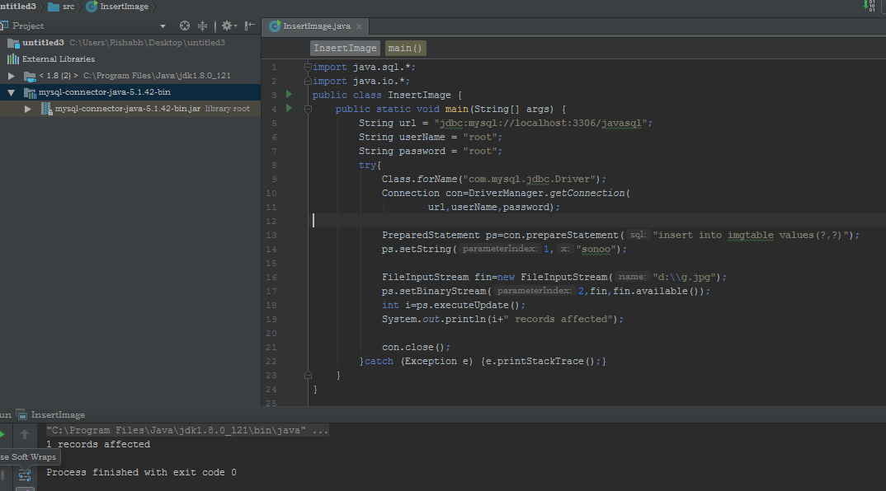

# Example to retrieve image from Oracle database->

# 

# 

# After this sonuu.jpg is creted in d drive->

# 